Affiliated to Pokhara University
POKHARA ENGINEERING COLLEGE
Phirke, Pokhara-8
1999

A
Mid-Term Report on
KeyDash
Submitted by:  Britant Shrestha (22070449)  Manish Shrestha (22070452)  Rijan Shrestha (22070458)  Ranjana Dhakal (22070457) | Submitted to:  Research Management Cell  Pokhara Engineering College  SUPERVISOR  Er. Shiva Ramdam
2025

Table of Contents
1. Introduction ...........................................................................................1
1.1 Background .....................................................................................1
1.2 Objectives ....................................................................................... 1
1.3 Problem Statement .......................................................................... 1
2. Literature Review .................................................................................. 2
3. Methodology ......................................................................................... 3
3.1 Approach ......................................................................................... 3
3.2 System Flow Diagram .....................................................................3
3.3 Progress Overview ...........................................................................3
3.4 Work Completed ............................................................................ 4
3.5 Tools and technologies ……………………………………………5
3.6 Project Timeline ...............................................................................6
3.7 Challenges Encountered...................................................................6
3.8 Current Status ................................................................................. 6
4.Testing and Future Work .......................................................................7
4.1 Testing..............................................................................................7
4.1 Test Cases ........................................................................................7
4.2 Future Works ...................................................................................7
5. Conclusion.................................................................................……….7
5.Reference……………………………………………………………….8

Chapter 1: Introduction

1.1 Background
In today's digital age, typing speed accuracy, and adaptability across languages and coding are essential skills for students, professionals, developers, and casual users alike. "KeyDash" is an upgraded web-based application designed to evaluate typing speed in words per minute (WPM) and accuracy while providing a user-friendly interface. It now offers multilanguage support, coding practice, multiplayer typing races, AI-based battle modes, symbol mastery, gamification elements like achievements and streaks, and social media sharing. The project leverages modern web technologies like HTML, Tailwind.css, Supabase (PostgreSQL), and React.js to create an interactive and responsive tool.

1.2 Objectives
The primary objectives of KeyDash are:
- To develop a responsive and interactive typing tester with multilanguage support, coding and symbols typing models, real-time multiplayer competitions, AI-based typing battles, and detailed performance tracking using HTML, React.js.
- To provide real-time WPM, gaming features like daily streaks, leaderboards, and one-click social media sharing to enhance user engagement.

1.3 Problem Statement
Existing typing test applications often suffer from outdated designs, limited functionality, and a lack of engaging features. Many fail to provide real-time feedback on essential performance metrics such as words per minute (WPM), typing accuracy, and error counts. They lack advanced features that are crucial for comprehensive skill development, such as multi-language support, coding, mastery of symbols and special characters. Additionally, existing platforms rarely include motivational and engagement-driven elements like daily streaks, challenges, achievements, multiplayer and leaderboards. KeyDash seeks to address these shortcomings by delivering a modern, interactive, feature-rich typing platform.

Chapter 2: Literature Review
Typing speed and accuracy have long been recognized as essential skills in both educational and professional environments. Traditional typing platforms, such as 10FastFingers, primarily focus on measuring words per minute (WPM) and basic accuracy. While they provide a quick assessment of typing ability, these platforms often lack personalized feedback and adaptive difficulty, limiting their effectiveness.
Research has shown that accurate typing reduces cognitive load, allowing users to focus more on content creation rather than the mechanics of typing. Karat et al. (1999) highlighted that improving typing accuracy helps minimize errors and reduces mental strain. Similarly, Rogers and Monsell (1995) found that faster typing speeds significantly reduce task completion time in computer-based workflows. Recent studies emphasize the importance of interactive learning tools, with Chen et al. (2021) demonstrating that providing real-time feedback and analytics during skill development enhances retention.
Current typing applications also show a lack of catering to specialized typing needs. For example, coding typing modes for programming languages like Python, and JavaScript are rarely available. Similarly, typing mastery of symbols, multiplayer races, and special characters is often neglected. KeyDash aims to address these gaps by providing an interactive and feature-rich typing platform that encourages consistent improvement and makes learning enjoyable.

Chapter 3: Methodology

3.1 Approach
- Agile Development: Iterative sprints with GitHub for task tracking.
- Tech Stack:
Frontend: React.js (hooks, components), Tailwind.css for styling.
Backend: Supabase for authentication, saving history, and leaderboard storage.
Storage: Supabase storage (Share cards and assets).
- Security: Row Level Security (RLS).
- Version Control: GitHub (branches, pull requests).

3.2 System Flow Diagram
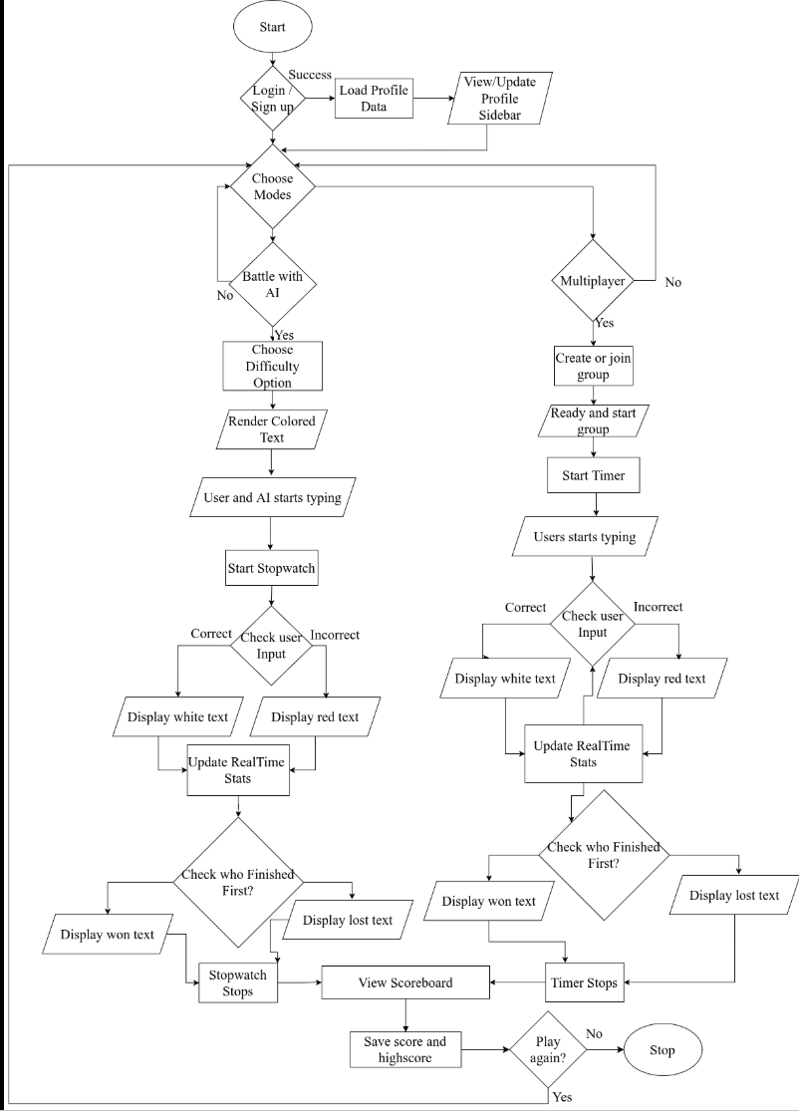

Chapter 4: Progress Overview

4.1 Work Completed
- Requirement Gathering: Completed through user research and analysis of existing platforms.
- Planning Phase: Defined sprint cycles using Agile methodology and established milestones.
- UI/UX Design: Designed initial wireframes and components for React-based frontend using Figma.
- Frontend Development (Phase 1):
Implemented base structure using React.js and integrated Tailwind.css for styling.
Created dynamic typing interfaces for multi-language typing (English and Nepali).
Developed the core logic for the timer system and real-time WPM/accuracy updates.
- Backend Setup: Initialized Supabase for authentication and leaderboard

5.2 Project Timeline
Week | Activities
1-2 | Requirements gathering, system setup, and UI/UX design in Figma.
3-4 | Planning the file structure, assigning roles, and Supabase configuration.
5-8 | Implement core typing modes, coding syntax logic, and multi-language support.
9-10 | Finalizing AI battles, multiplayer modes, testing, and deployment documentation.

Chapter 6: Challenges Encountered
- Real-Time Feedback: Ensuring accurate and instant updates of WPM and typing accuracy.
- User Interface: Implementing color-coded feedback (green for correct and red for incorrect characters) smoothly.
- Typing Modes Integration: Managing different typing modes, including normal text, coding snippets(python and C++), and Nepali Unicode text.
- Backend Setup: Configuring Supabase for real-time multiplayer races .

Chapter 7: Current Status
Module | Status
Requirements Gathering | Completed
Planning & Design | Completed
Frontend Core Development | Completed
Advanced Typing Modes | Completed
Supabase Authentication & Storage | Completed
Testing & Bug Fixing | In progress
Documentatiom | In Progress
Download Result card | In progress

Chapter 8: Testing and Future Work

8.1 Testing
To ensure the reliability and effectiveness of the KeyDash application, various test cases were executed during the development process. The testing focused on typing habits and behaviors after incorrect character input attempts, entering Unicode characters for multi-language support, and verifying real-time tracking.

8.2 Test Cases
S.N | Test Case Description | Result
1 | Restart the Dashboard for next display text. | Pass
2 | User input correct key as per the displayed text. | Pass
3 | User input incorrect key as per the displayed text. | Pass
4 | User input space before the completion of the word. | Pass
5 | Verify multi-language switch (English to Nepali). | Pass
6 | Show real time WPM and accuracy. | Pass

8.3 Future Works
- Finalize all advanced typing modes, including coding.
- Complete real-time multiplayer typing races and social media sharing integration.
- Complete medal name integration within the dashboard system.
- Implement comprehensive storage of past data via Supabase.
- Finalize gamification elements (daily streaks, challenges, achievements).
- Begin drafting the user manual and final deployment documentation.

9. Conclusion
We’ve finished the planning, design, and frontend for KeyDash. Multi-language support and typing modes are working well.We’re now polishing multiplayer and gamification on the backend, but the core is solid and we’re on track to build a smooth platform for typing and coding practice.

Chapter 9: References
- 10FastFingers. (n.d.). 10FastFingers. https://10fastfingers.com
- Typeshala. (n.d.). Typeshala. http://typeshala.shresthasushil.com.np/
- Chen, Y., Chen, Y., & Huang, Y. (2021). Adaptive feedback systems and their impact on learning performance: A meta-analysis. Computers & Education, 174, 104309.
- Deterding, S., Dixon, D., Khaled, R., & Nacke, L. (2011). Gamification: Toward a definition. CHI 2011 Conference on Human Factors in Computing Systems, 12-15. https://doi.org/10.1145/1979742.1979575
- Rogers, R. D., & Monsell, S. (1995). Costs of a predictable switch between simple cognitive tasks. Journal of Experimental Psychology: General, 124(2), 207-231.
- Zhang, L., & Sun, T. (2023). Real-time feedback systems in typing tutors: A WebSocket-based approach. Journal of Educational Technology & Society, 26(1), 89-102. https://doi.org/10.2307/jeductechsoci.26.1.89

